**Project FAIRNESS - Financial Skills foR busiNEss Startups Smes.**

**Project FAIRNESS addresses the priority of creating and promoting learning opportunities in the inter-generational context of family-run businesses, particularly the SMEs.**

The project FAIRNESS results:

1. A assessment of the various current financial and capital solutions in each represented jurisdiction
2. A self-assessment tool for needs and business structure analysis
3. A training module for development in seeking financing solutions

The project FAIRNESS consortium:

| **ROLE** | **ORGANISATION** | **COUNTRY** | **WEBSITE** |
| --- | --- | --- | --- |
| Coordinator | Malta Stock Exchange | Malta | www.borzamalta.com.mt |
| Partner | Meta4 Innovations e. U. | Austria | www.meta-4.org |
| Partner | Vernian RTI | Cyprus | www.vernian.eu |
| Partner | Exeo Lab Srl | Italy | www.exeolab.it |
| Partner | South-west University Neofit Rilski | Bulgaria | www.swu.bg |
| Partner | European Projects and Training OOD | Bulgaria |  |

The project FAIRNESS is a Erasmus+ KA2 CP ADU financed project. The project duration is 24 months, from 01.09.2022 to 31.08.2024 and will be implemented by partners from Austria, Bulgaria, Cyprus, Italy and Malta.

The FAIRNESS project was kicked off via a virtual meeting. We have also initiated work on the Work Package “A critical assessment of the various current financial and capital solutions in each represented jurisdiction”.

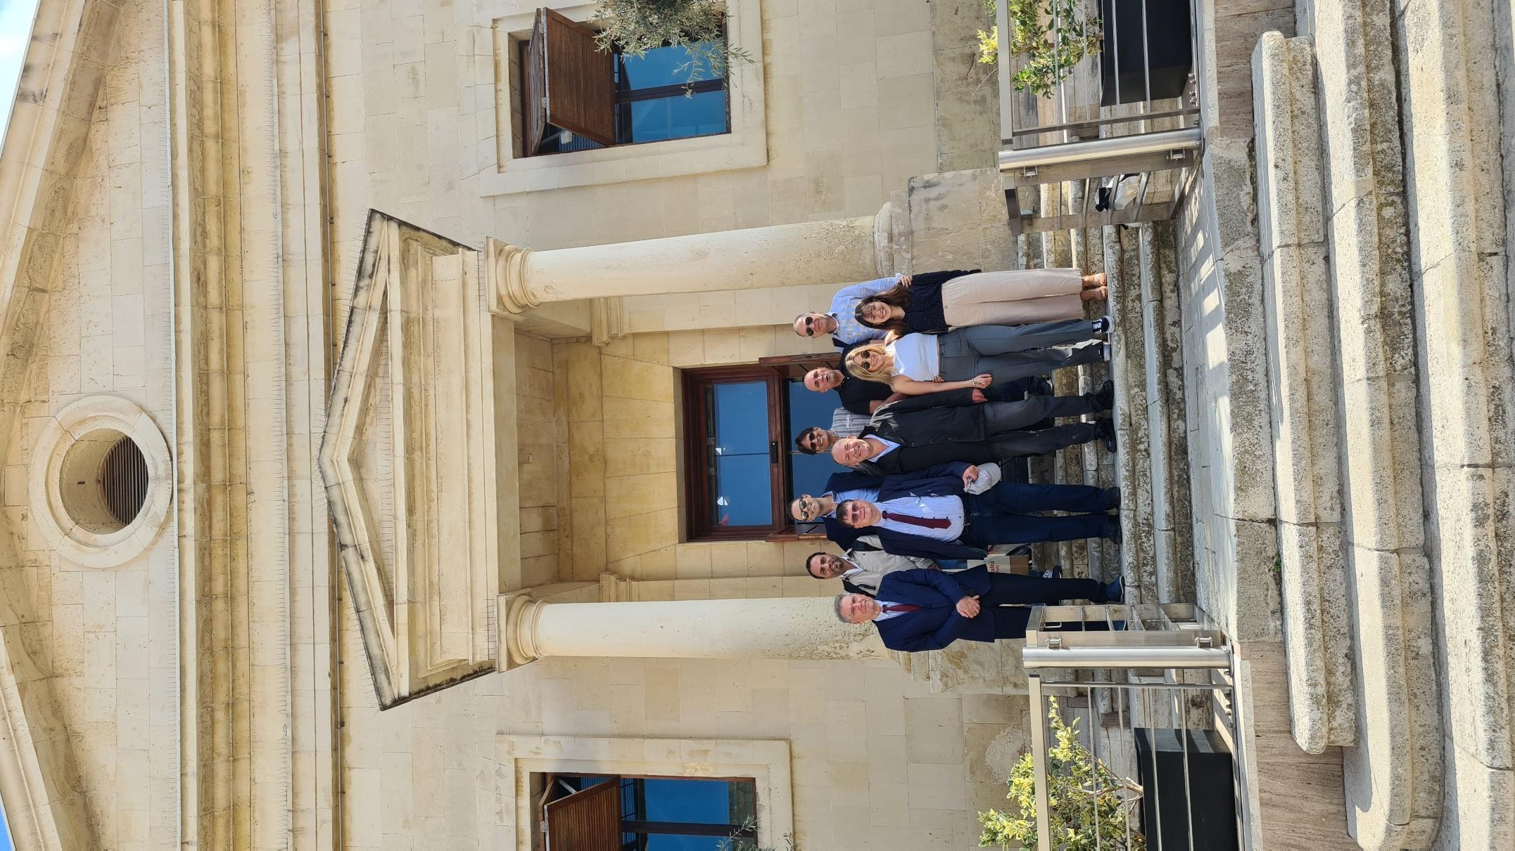

The FAIRNESS-project group organized the first project meeting on Malta from 20. – 21. October, 2022. The first group meeting on Malta was productive and supported the further progress. To communicate effectively with persons and organisations outside our consortium, the FAIRNESS-project will create social media presence.

The project website follows shortly and will have further details about the project, the outcomes, newsletters and events.